

|  |
| --- |
| Zero Feature Release |
| A program assisting healthily getting fat |



|  |  |  |  |  |
| --- | --- | --- | --- | --- |
| **제출일** | 2018. 5. 20. |  | **전공** | 컴퓨터공학부 |
| **과목** | 소프트웨어공학 |  | **학번** | 20141405 |
| **담당교수** | 송인식 |  | **이름** | 최형준 |

***Contents***

1. Documentation for Users - p3
2. A description of your project - p3
3. How a user obtains and install the software (including prerequisites) - p4
4. How to run the software - p8
5. A high-level description of the user view of your software - p10
6. How to use the software - p13
7. How to report a bug - p14
8. Documentation for developers - p16
9. How to obtain the source code - p16
10. The layout of your directory structure - p17
11. How to build the software - p17
12. How to test the software - p18
13. How to set up an automated daily build and test - p19
14. How to release a new version of your software - p19
15. How to access the list of outstanding bugs and the list of resolved bugs, and how to resolve a bug - p20
16. Example of source code - p20
17. Documentation for Users
18. A description of your project
19. Product Introduction

“Fatter” application is aprogram that assists low weight people healthily getting fats. Low weight people have a greater chance to suffer from diseases such as pneumothorax than others.

On the internet or in app markets, all fitness programs focus on losing weights. Through providing useful information to get fat, this program will uniquely help lowweight people.

1. Project Details

|  |  |
| --- | --- |
| Number of team members / Development Method | 6 people / pair programming |
| Software Tools | 1. Java Swing – for making GUI  2. Jsoup – for crawling  3. Eclipse – for compiling java codes |
| Design Model  MVC model |  |
| Programming Language | Java |
| Testing Method | 1. Unit Test by JUnit  2. Class Test by testing *main function* in each class |
| Debugging Method | Debugging by eclipse debugger |

1. Application functions to implement

|  |  |
| --- | --- |
| Login Function | For discrimination of users |
| Registration Function | To get user’s information and make ID |
| Crawling | Get information from web DB |
| DB control function | Control the data program use in local/ |
| Alarm Function | Notify appropriate time to eat to user |
| Controller/View | Using java swing make views and using views to get command from user in controller |
| Arithmetic Operation | Calculations used in application |

1. How a user obtains and install the software (including prerequisites)
2. Prerequisite

* Java Download

1. Download Java from [https://java.com/ko/download/.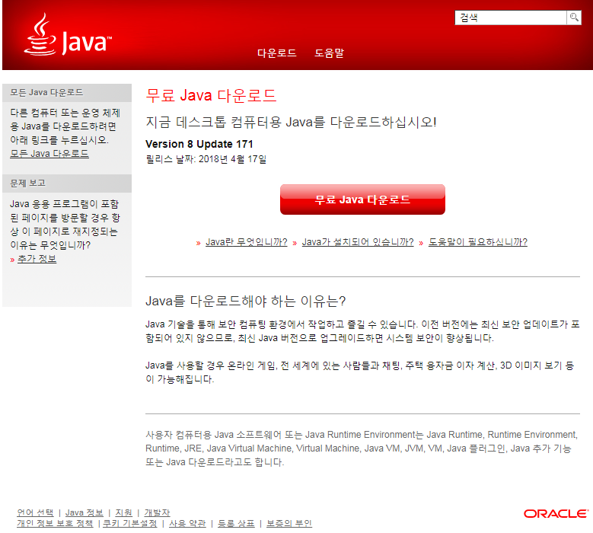](https://java.com/ko/download/.)
2. Install the downloaded file.

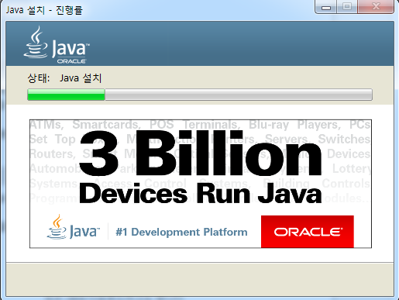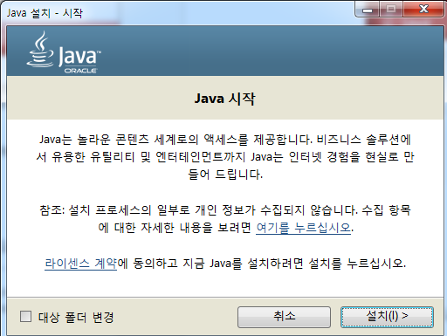

1. You are ready to run “Fatter” application.

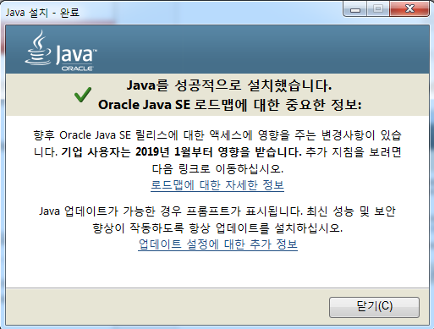

* Java JRE Download

1. Click JRE Download from <http://www.oracle.com/technetwork/java/javase/downloads/index.html>.

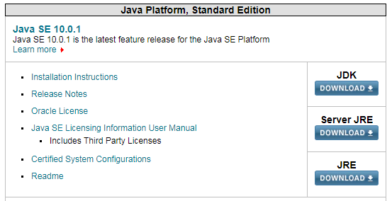

1. Select an install program according to the operation system.

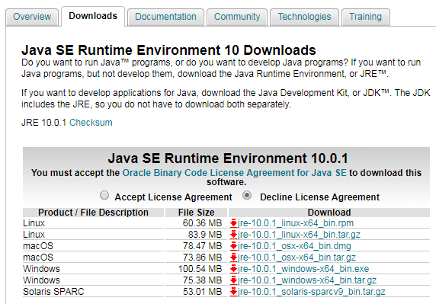

1. Install the downloaded file.

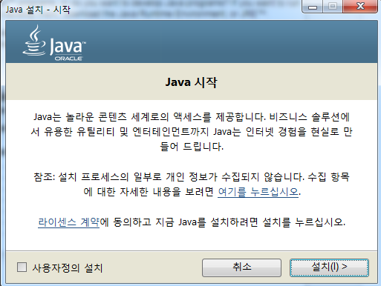 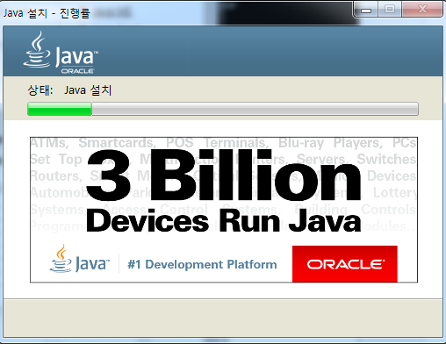

1. You are ready to run “Fatter” application.

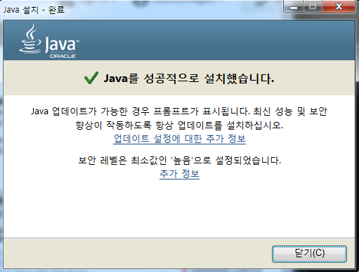

1. How to install
2. Enter the *github.com* in web. Type “Fatter” in search field

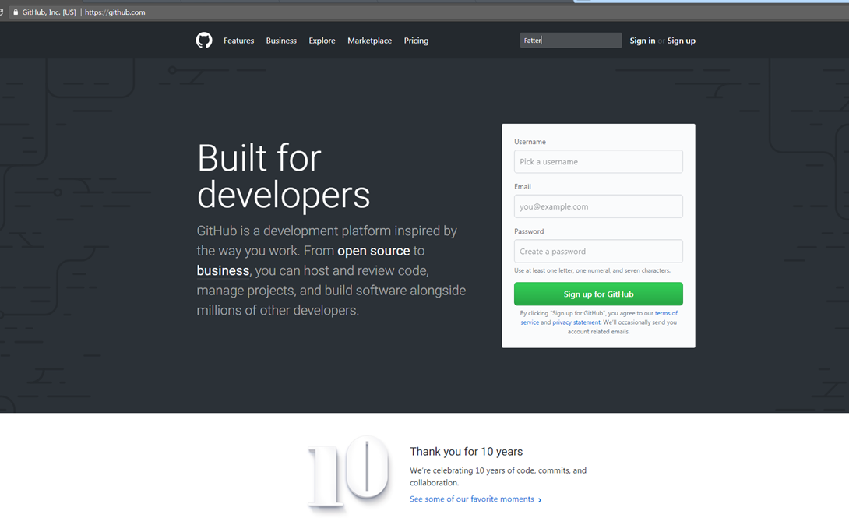

1. From search result find “Fatter/HyungjuneC” , click.

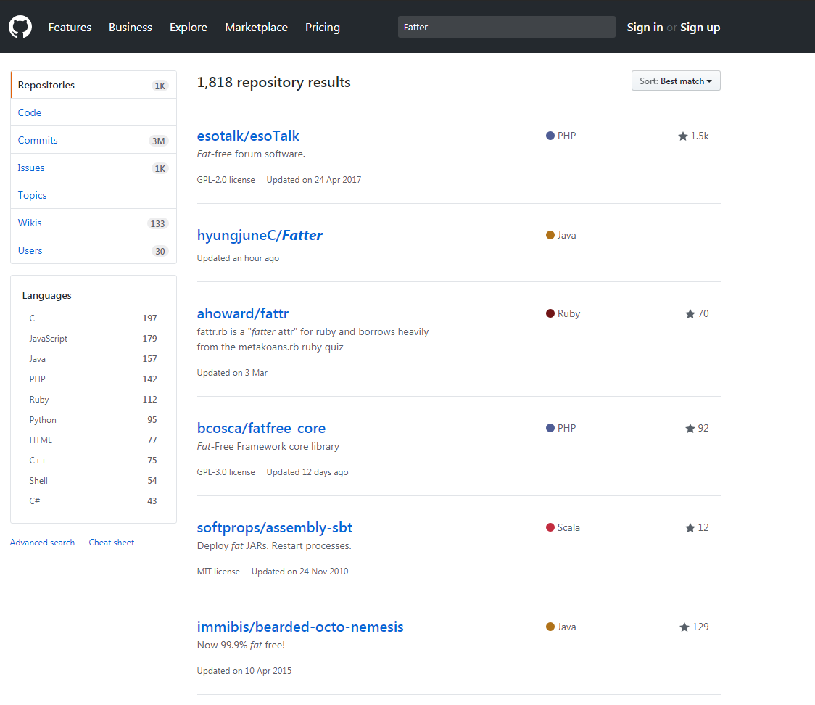

1. In main page of our project, click clone or download

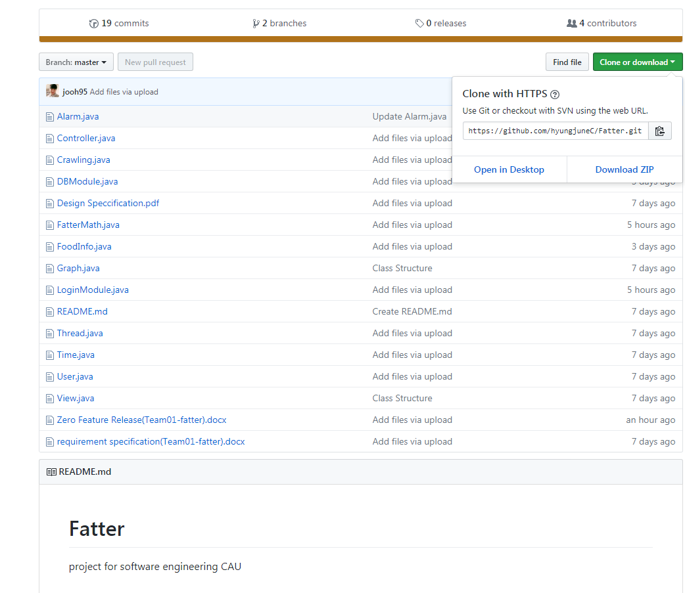

1. How to run the software
2. Icon based method
3. exe file should be located in the certain directory. Therefore, the file must not be moved to other places.
4. Double click the program icon.



*.exe file is made by JSmooth*

1. Command line based method
2. Go to the system configuration.

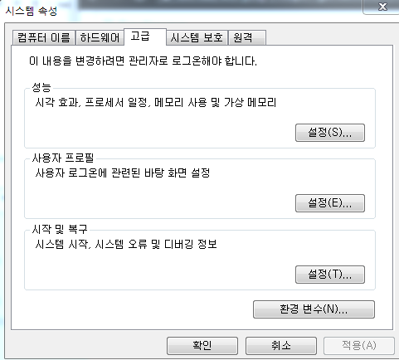

1. Insert java jre path into the computer system variable, *Path*.

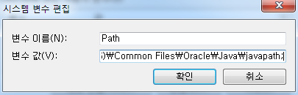

Ex) C:\Program Files (x86)\Common Files\Oracle\Java\javapath;

1. Type the running –jar command in cmd.



Command: java –jar *program_path*

1. A high-level description of the user view of your software

- Login UI

**Fatter**

**ID**

**Password**

Login

**Registration**

- GetUserInfo UI

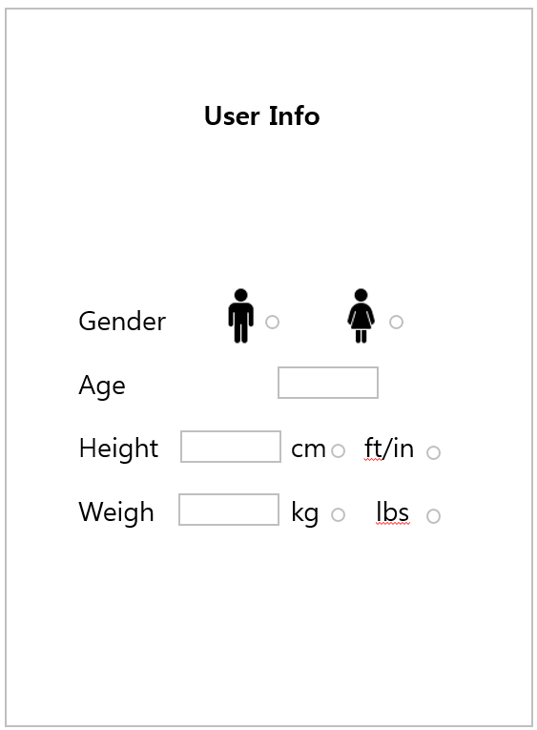

- Main UI

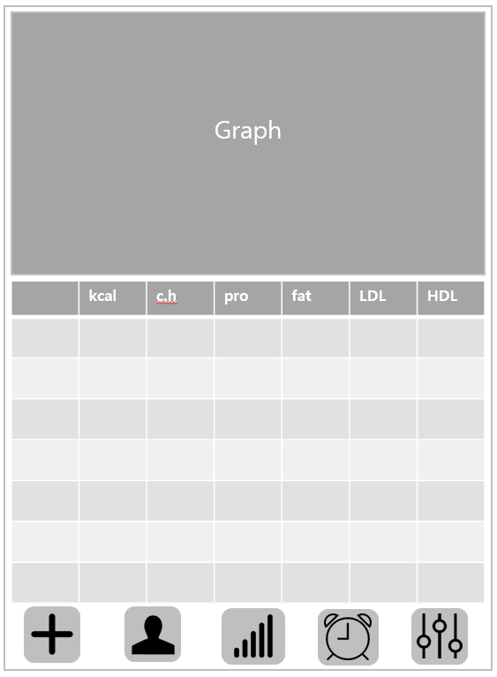

- Registration UI



ID

Password

**Confirm**

PW confirm

- Setting UI

**Setting**

Used days : 27 days

User ID: Honggildong

First weight: 50kg

Current weight: 55kg

**Logout**

- Alarm UI

**Alarm**

Remain time for Alarm:

02:23:12

Last Eaten time:

12:00:00

**X**

- Evaluate food & addition

**Food Addition**

Food

**Add**

kcal

protein

fat

carbo

1. How to use the software
2. 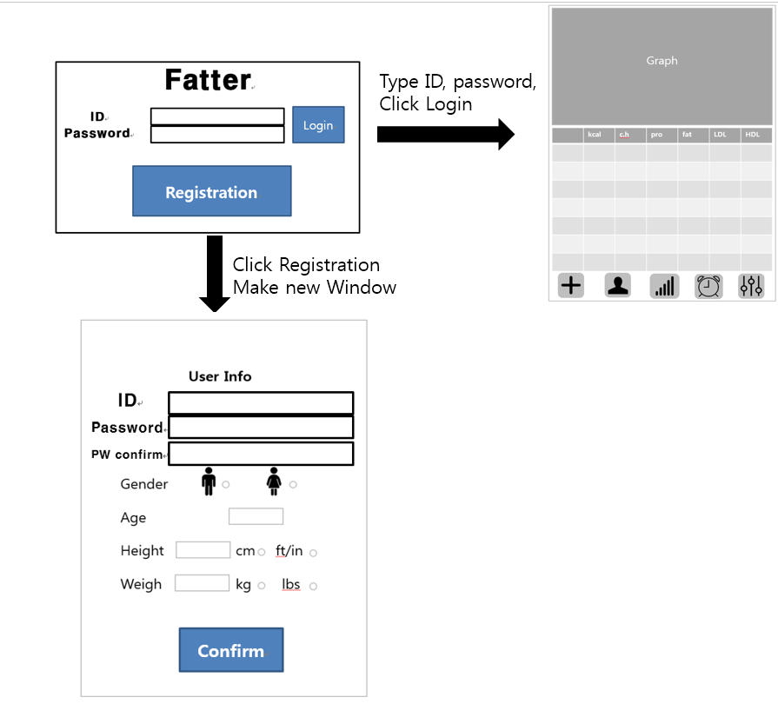when user run application, Login UI show up From UI login,

From Main UI,

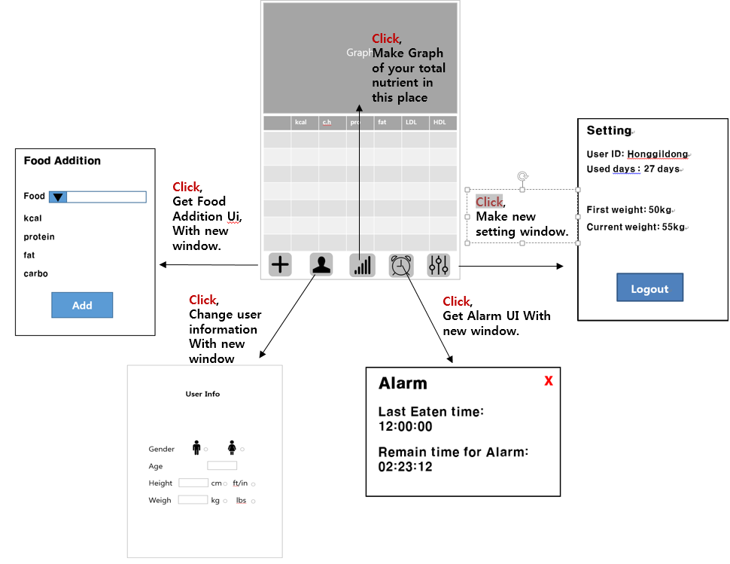

1. How to report a bug
2. Report a bug from the issue section in Github. Github Address is <https://github.com/hyungjuneC/Fatter> (hyungjuneC / Fatter)
3. Click new issue button in the issue section.

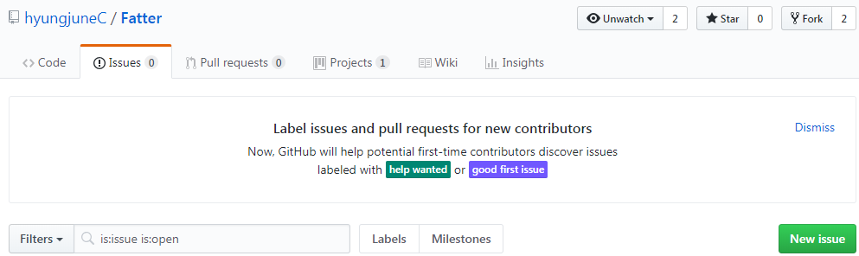

1. Write down the bug on the project.

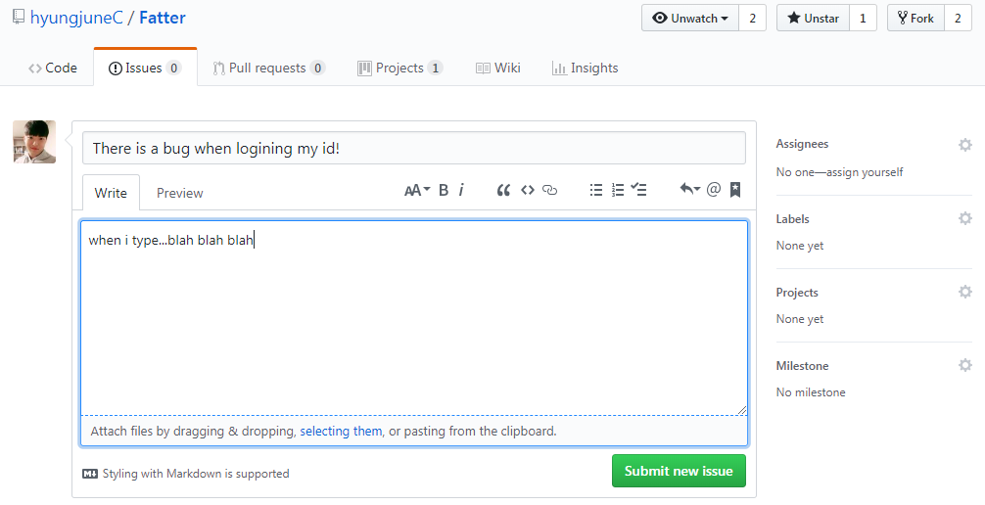

1. There will be a solution proposed by the developers or other users.

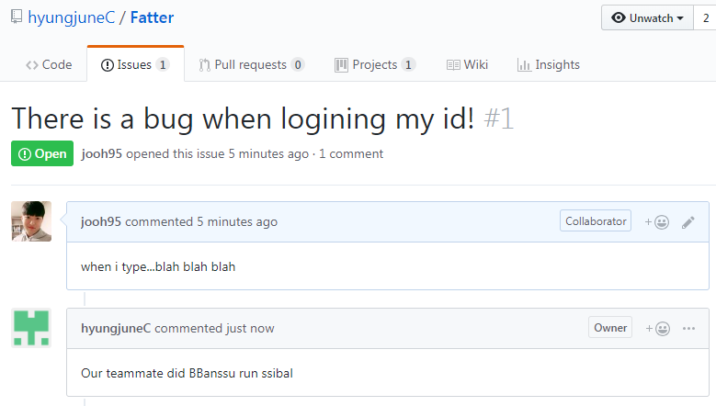

1. Report a bug from email.

Contact us. <mailto:sangpon@naver.com>

1. **Documentation for developers**
   1. How to obtain the source code
2. Every single source code is uploaded to Github. Github Address is <https://github.com/hyungjuneC/Fatter> (hyungjuneC / Fatter)
3. Go to “*Fatter*” Github website.

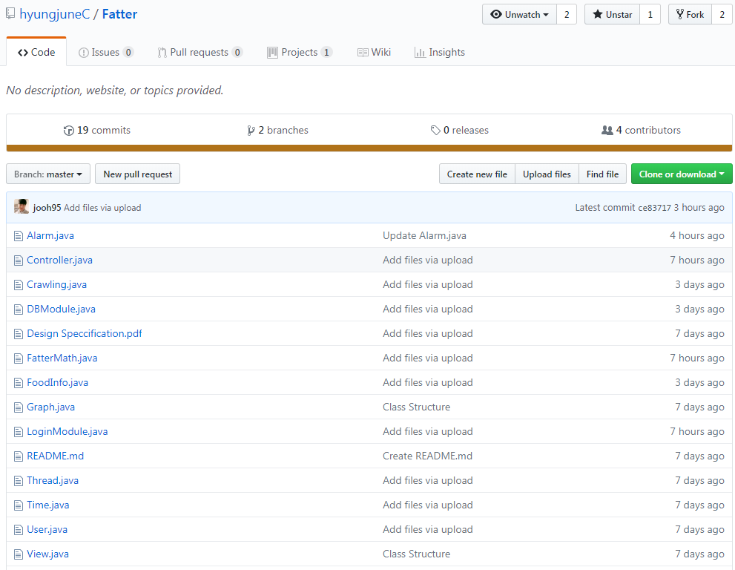

1. Click the green “Clone or download” button and download all source codes.

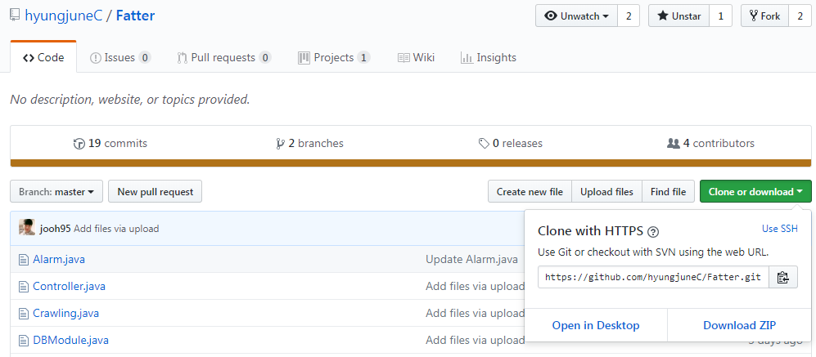

* 1. The layout of your directory structure

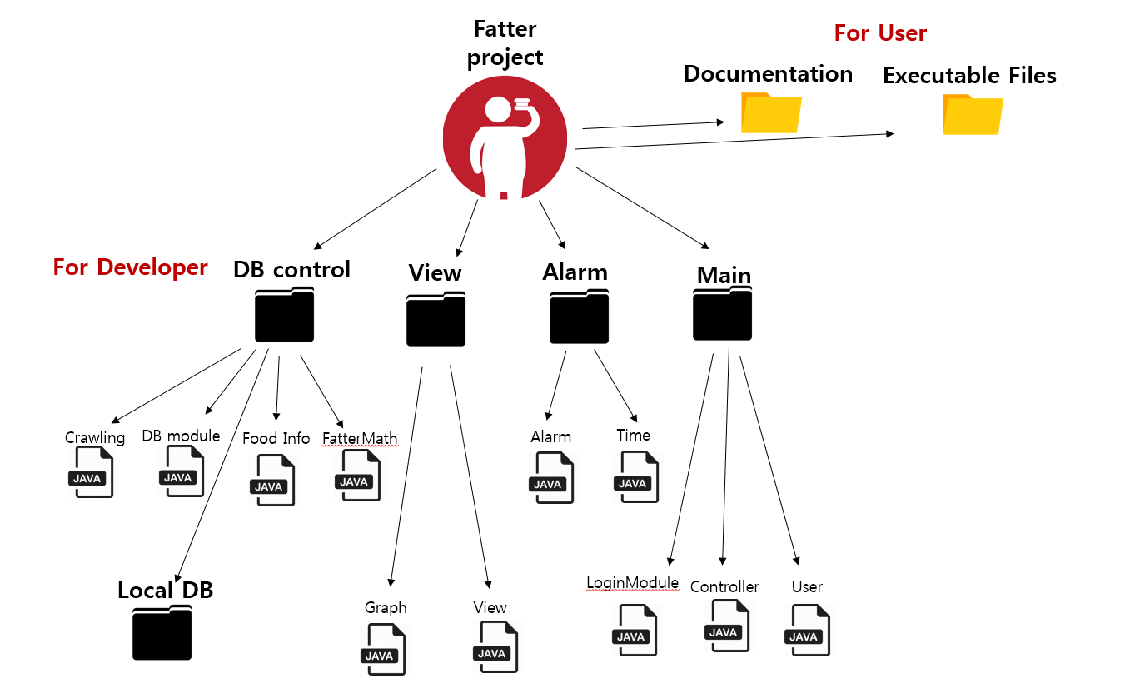

* 1. How to build the software
     + 1. Click *“Project”* in the eclipse tool bar.

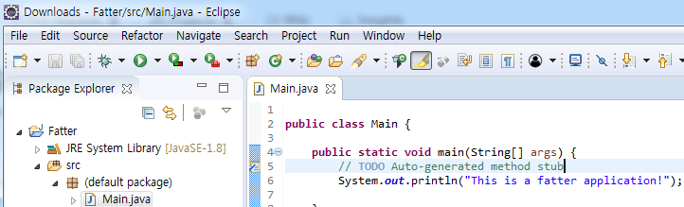

* + - 1. Click “build project” and the project is going to be built.

Ex) Project > Build project

* 1. How to test the software

|  |  |
| --- | --- |
| Unit Test | - Implement test cases for each methods in every class through JUnit.  Ex) junitì ëí ì´ë¯¸ì§ ê²ìê²°ê³¼ |
| Class Test | - Implement test cases in Main function of each class.  Ex) |

* 1. How to set up an automated daily (or more frequent) build and test

1. Use automated build tool, ***Apache Ant***

Set *build.xml* for project name, directory path etc. Apache Ant will build the project automatically.

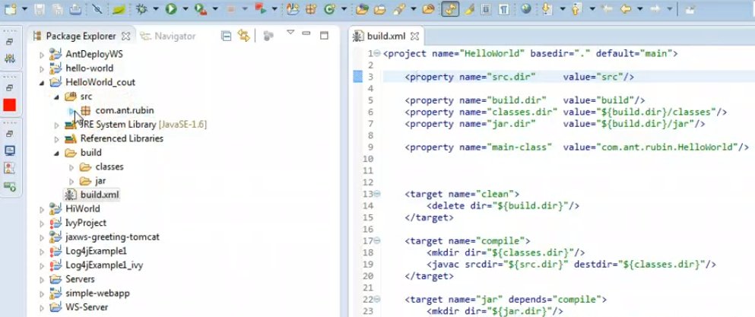

* 1. How to release a new version of your software

All changes, including new versions release, will be announced and distributed via our Github (<https://github.com/hyungjuneC/Fatter> [hyungjuneC / Fatter] ). We will use the branch in Github. Below image is an example of creating a new branch for the new version of source code.

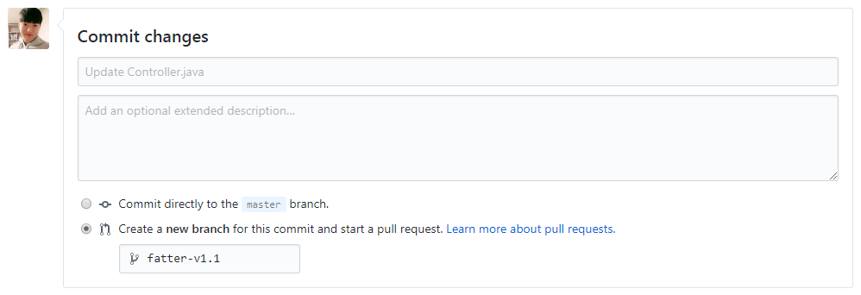

* 1. How to access the list of outstanding bugs and the list of resolved bugs, and how to resolve a bug

1. How to access the list of outstanding bugs

The list of outstanding bugs and the list of resolved bugs are in our Github - issues tab. At the same time, we receive user bug report through email.

1. We resolve a bug this way

find a bug occurred section in code, write a code according to the bug occur scenario, and unit test by using Junit.

* 1. Example of source code

1. FatterMath

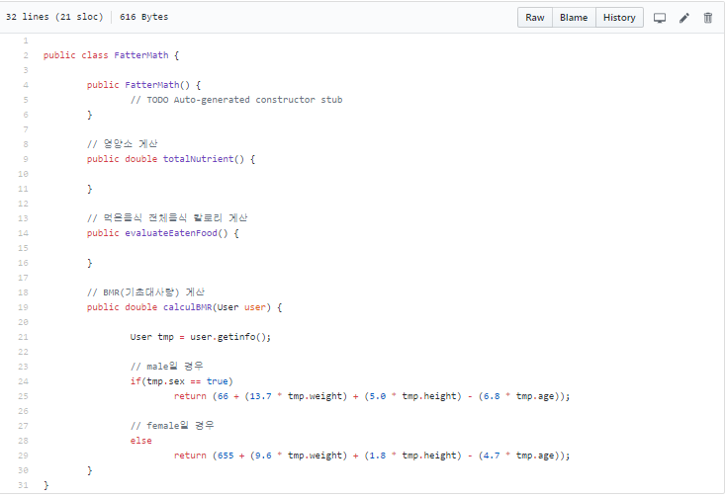

1. Controller

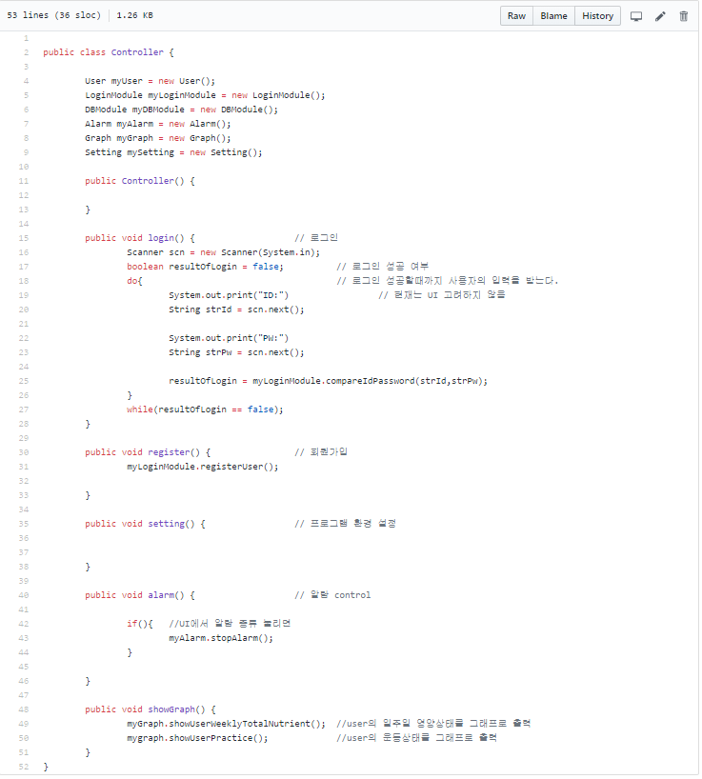

1. LoginModule

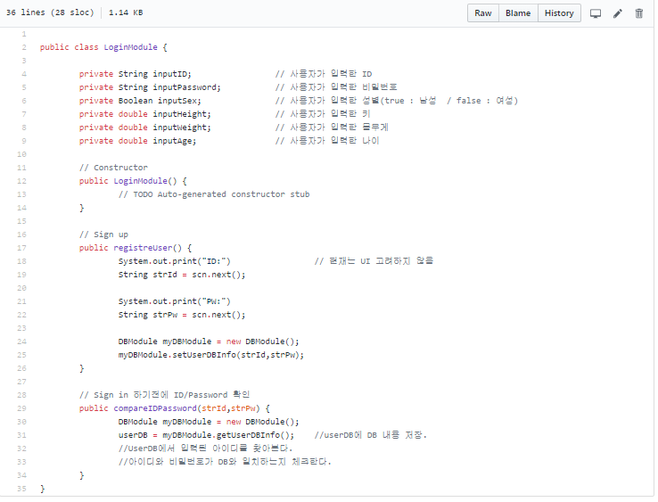

1. User

